**Translation Apps**

**Unregistered User**

**Homepage**

“TumuhanPerubatanMelayu” = Malay Medicinal Plants

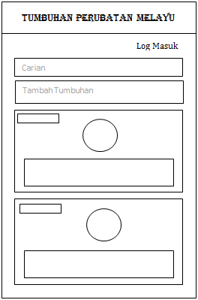

“Log Masuk” = Log in

Menu Button

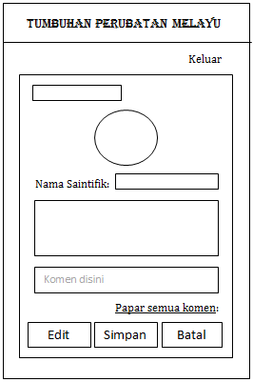

“Batal”=Cancel

“Simpan”=Save

“Edit”=Edit

“TambahTumbuhan” = Add plants

“Komen disini”= comment here

Log Masuk

Dieditoleh,

“Carian” = Search

Comment textbox

Description of medicinal plant

“Edited by”,

(Name of people who add or edit the information of that medicinal plant)

Full description of medicinal plant

Image of medicinal plant

Name of medicinal plant

Image of medicinal plant

Name of medicinal plant

Favorite Button

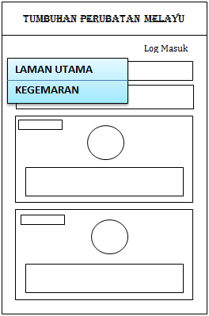

“Log Masuk”= Log in



“LAMAN UTAMA”= Main Menu



“Kegemaran”= favourite



“Log Masuk”= Log in

**Favorite Page**

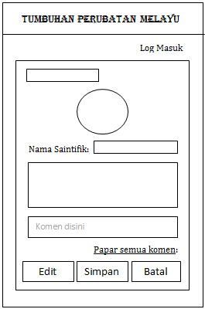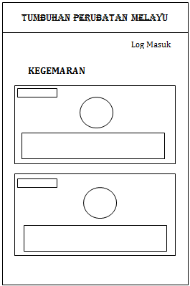







“KEGEMARAN” = favourite



Dieditoleh,

“Papar semua komen” = View all comments

“NamaSaintific” = Scientific Name

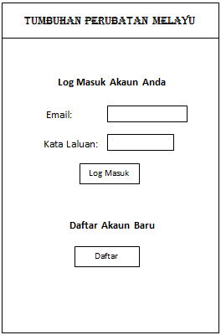

**Log in Page**



“Log MasukAkaunAnda” = Log in your account

**Sign Up Page**

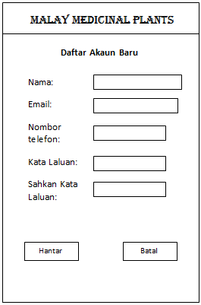

“Hantar” = Hantar / Save

“Batal” = Cancel

“Sahkan Kata Laluan” = Confirm Password

“Kata Laluan” = Password

“Nama” = Name

“Email” = Email

“Nombortelefon” = Phone number

“Daftar” = Register

“DaftarAkaunBaru” = Register New Account

“Log Masuk” = Log in

“Kata Laluan” = Password

“Email” = Email

**Registered User**

**Homepage**

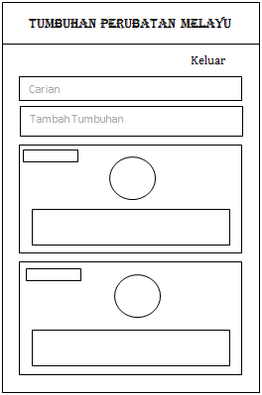



“Keluar” = Log out

“Carian” = Search

“TambahTumbuhan” = Add plants



Image of medicinal plant

Description of medicinal plant



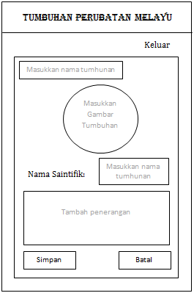



“Batal” = Cancel

“Simpan” = Save

“MasukkanNamaTumbuhan” = Add scientific name of medicinal plant”

“TambahPenerangan” = Add description of plant

“MasukkanGambarTumbuhan = “Add image of medicinal plant”

“Masukkannamatumbuhan” = Add name of plant

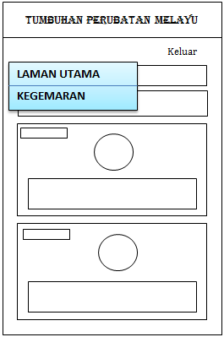

“Keluar” = Log out

“LAMAN UTAMA” = Main menu

“KEGEMARAN” = Favourite





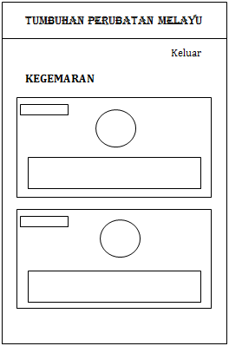

“Keluar” = Log out

“Keluar” = Log out

**Favorite Page**

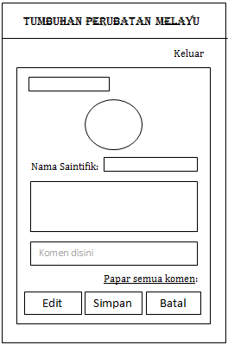



“Simpan”=Save

“Batal”=Cancel

“Edit”=Edit

“NamaSaintifik” = Scientific name

“KEGEMARAN” = Favourite

Dieditoleh,



“Keluar” = Log out

Edited by,

If users click here, then it will go to the plant page

“TambahTumbuhan” = Add plant out

“Papar semua komen”= View all comments

“Komen disini” = Comment here out

“Batal”=Cancel

“Simpan”=Save

“Edit”=Edit

Dieditoleh,

“Dieditoleh” = Edited by out

“Keluar” = Log out

“NamaSaintifik” = Scientific Name

“Carian” = Search

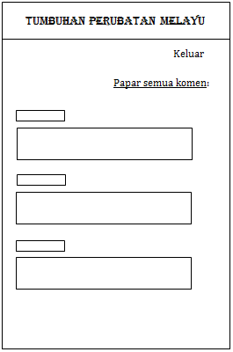

“Papar semua komen”=View all comments

“Simpan”=Save

“Batal”=Cancel

“Edit”=Edit

“NamaSaintifik”= Scientific name

“Papar semua komen”=View all comments

“Keluar”=Log out

“Keluar”=Log out

Note: Only the information of user is keep in the database.